**Fuzzification Techniques**

**Intuition**: Intuition method is based upon the common intelligence of human. It is the capacity of the human to develop membership functions on the basis of their own intelligence and understanding capacity. There should be an in-depth knowledge of the application to which membership value assignment has to be made.

The Figure below shows various shapes of weights of people measured in kilogram in the universe. Each curve is a membership function corresponding to various fuzzy (linguistic) variables; such as very light, light, normal, heavy and very heavy.

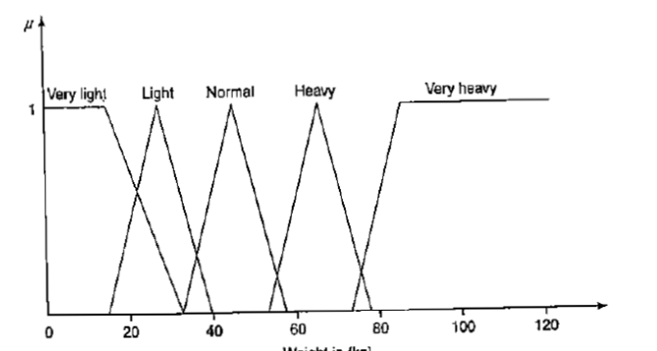

**Inference:**

Here the knowledge of geometrical shapes and geometry is used for defining membership values. The membership functions may be defined by various shapes: triangular, trapezoidal, bell-shaped, Gaussian and so on. The inference method here is discussed via triangular shape.

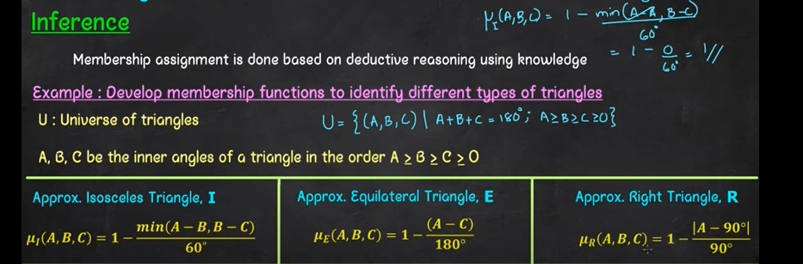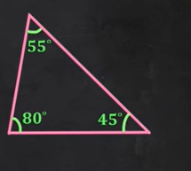

**3. Rank Ordering**

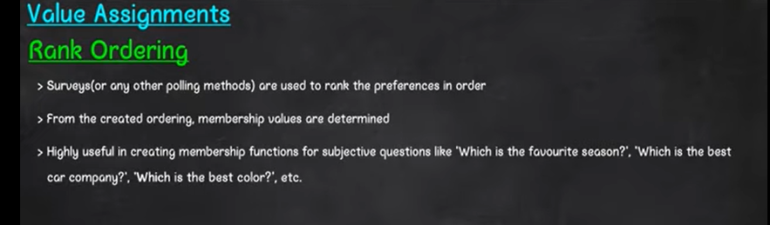

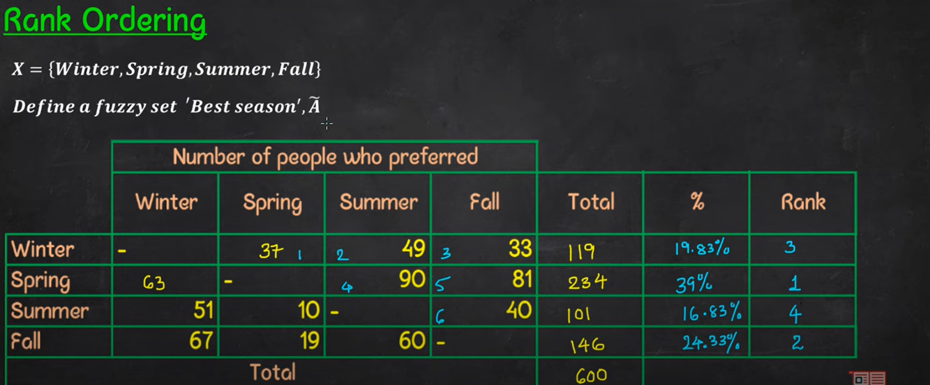

**4. Neural Networks**

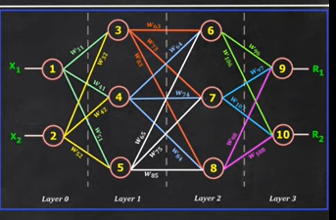

**5. Genetic Algorithm**

**6. Inductive reasoning**

**09, 0.12, 0.15, 0.18, ……..**

**1,2.3.4, ……**

**Observations + Experimental Information = Conclusion**

**Defuzzification Techniques**



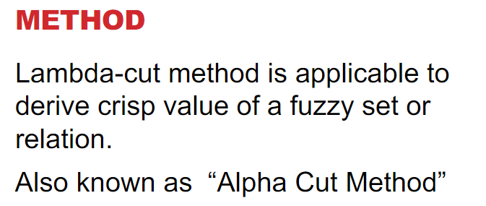

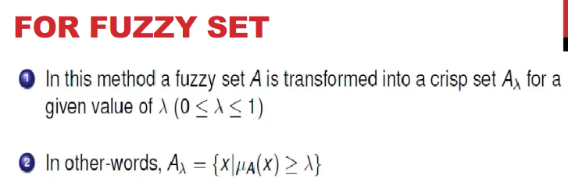

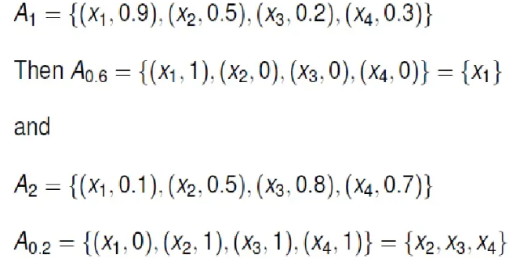

**2. Maxima Method**

